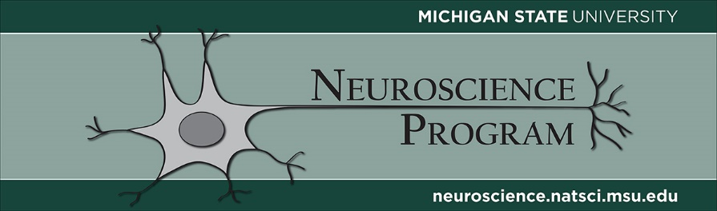

FALL 2020 SEMINAR SCHEDULE

MONDAYS AT 4:00 PM
JOIN US VIA ZOOM: https://msu.zoom.us/j/2551861267
PASSCODE: 900833

9/7 NO SEMINAR – Labor Day

9/14 Meet the New Graduate Students!

Please join us as our new graduate students virtually introduce themselves to the program.
Michigan State University
Host: Dr. James Galligan

9/21 Daniel Suter

The role of forces in neurite outgrowth
Purdue University
Host: Dr. Kyle Miller

10/5 William Atchison

Diversity Training and its Role in the Neuroscience Program
Michigan State University
Host: Dr. James Galligan

10/12 Assaf Gilad

Bioengineering of Synthetic Tools for Probing Cell-Specific and Circuit-Specific Neuronal Processes
Michigan State University
Host: Dr. James Galligan

10/19 No Seminar – Open Date

10/26 NO SEMINAR – Fall Break

11/2 Alexa Veenema

Function of sex differences in the brain for the regulation of social behavior: Insights from vasopressin and oxytocin
Michigan State University
Host: Dr. James Galligan

11/9 Joseph Lonstein

Plasticity in central serotonin across female reproduction and role in postpartum socioemotional behaviors
Michigan State University
Host: Dr. James Galligan

11/16 Jessica Damoiseaux

Neural correlates of cognitive aging and risk factors for cognitive decline.
Wayne State University
Host: Zac Fernandez

11/23 Debajit Saha

Chemical Sensing in Biological Olfaction: from Neural Computation to Bio-robotics
Michigan State University
Host: Dr. James Galligan

11/30 Luis Martinetti

Proposal Defense**
Michigan State University
Host: Dr. James Galligan

12/7 NSP Faculty meeting
**Proposal Defense
*** Dissertation Defense Seminar

All seminars will be broadcast to 1102A&B Grand Rapids Research Center

